Florianópolis, 17th September 2018

Dear Professors Jonato Prestes and Junior Vagner Pereira da Silva (Editors-in-Chief of Brazilian Journal of Science and Movement)
Please find here enclosed a paper (Original Investigation) that I would like to submit for publication to the Brazilian Journal of Science and Movement “Body fat percentage and lower limbs temperature in recreational cyclists during an incremental test”, authored by Lucas Tavares Sampaio, Karla de Jesus, Alexandre Igor Araripe Medeiros and Vinicius Cavalcanti.
As corresponding author (e-mail: lucedfiscia@gmail.com; mobile phone +5592982494756; address: UFSC - Câmpus Trindade, Av. César Seara - Carvoeira, Florianópolis – SC, S/N) and on behalf of all the authors, I would like to convey that this is an Original Research which attempts to increase either information on cyclists’ skin temperature response in an incremental test and testing cyclists with different percentages of fat. Therefore, we tried to understand if in individuals with the same training level the different percentage of fat could cause different responses.
We believe that the conceptual and methodological design included complies with the quality standards of the Brazilian Journal of Science and Movement and adds relevant contribution for cyclists and coaches, helping to understand how the temperature transferred to the skin behaves during cycling in individuals with different fat percentages.
This manuscript contains original material that has not been previously published and neither is currently under consideration nor will be submitted elsewhere until the Brazilian Journal of Science and Movement has made a final decision. The manuscript contains nothing that is abusive, defamatory, libellous, obscene, fraudulent or illegal. Ethical procedures are also clearly described in the Methods section of the manuscript.
All authors have read and concur with the content in the manuscript and have also given substantial contributions to all of the following: (1) the conception and design of the study, acquisition, analysis and interpretation of data, (2) drafting the article and revising it critically for important intellectual content and (3) final approval of the version submitted. All authors have agreed with the order of authors’ name, and have authorized the corresponding author to act as an agent on their own behalf in all matters pertaining to manuscript publication.
Furthermore, all the authors state the inexistence of conflicts of interest regarding this publication and they all agree that, once accepted for publication at the Brazilian Journal of Science and Movement, all the publication rights will be transferred to this prestigious Journal.

I look forward to hearing from you soon, please accept my best regards,

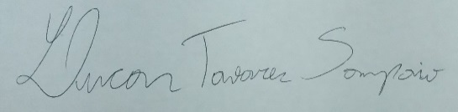
Lucas Tavares Sampaio

