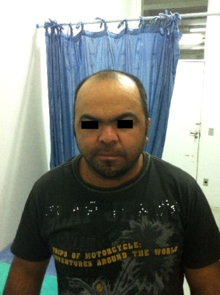

Figure 1. Patient JMC with arched and fused eyebrows, prognatism, and a characteristic “coarse face”.

